**LAB 2**

ANUDIT NAGAR – E18CSE024

Question 2 – Client_Master

|  |  |  |  |  |
| --- | --- | --- | --- | --- |
| Client_No | Fname | City | Pincode | Bal_due |
| C00001 | SMITHA JAIN | Mumbai | 400054 | 15000 |
| C00002 | VANDANA RAO | Chennai | 780000 | 0 |
| C00003 | PREM PUJARI | Mumbai | 400057 | 5000 |
| C00003 | PREM PUJARI | Mumbai | 400057 | 5000 |
| C00005 | RAVI SHANKAR | Delhi | 100001 | 2000 |
| C00006 | ROOPA | Mumbai | 400050 | 0 |

Query 1 )

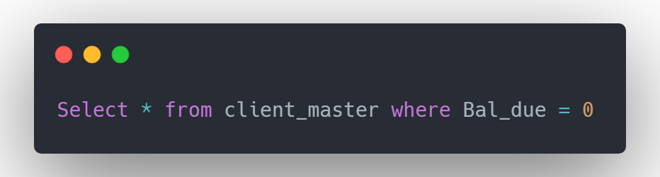

Output 1 )

|  |  |  |  |  |
| --- | --- | --- | --- | --- |
| Client_No | Fname | City | Pincode | Bal_due |
| C00002 | VANDANA RAO | Chennai | 780000 | 0 |
| C00006 | ROOPA | Mumbai | 400050 | 0 |

Query 2 )

Output 2 )

|  |  |  |  |  |
| --- | --- | --- | --- | --- |
| empcode | empname | address | age | deptcode |
| E105 | Daisy | Chaithram, Angamaly | 35 | D707 |
| E108 | Prakash | Vennikulam | 36 | D110 |
| E111 | Deva | Trichy | 38 | D301 |

Query 3 )

Output 2 )